HSE OPERATIONAL
PATHWAYS OF CARE
For the Assessment and Management of Patients with Covid-19

Date: 19 March 2020

Executive Summary 3
1. Background and Context 4
1.1 Epidemiology 4
1.2 Clinical Considerations 5
2. Scope 6
3. Guiding Principles 7
4. Governance Structures 7
5. Model of Care 9
5.1 Core Principles for Stages of Disease Transmission 9
5.2 Delay Phase Patient Pathway 9
5.3 Mitigation Phase 10
5.4 Pathways of Assessment and Management in Community Hubs and Hospital Settings 11
5.5 Community Assessment Hubs 12
5.6 Acute Hospitals 14
5.7 Considerations for specific populations 17
6. Appendices 18
APPENDIX A: HSE & Department Health Governance Structures for COVID-19 19
APPENDIX B: OUTLINE MODEL OF CARE 20
APPENDIX C: Care Pathway for suspected or confirmed COVID-19 during Mitigation Phase 21
APPENDIX D: CONTACT MANAGEMENT SYSTEM 22
APPENDIX E: COVID – 19 Self Care Plan 23

Executive Summary

This document describes the pathways of care for patients diagnosed with Covid-19 and all pathways are underpinned by the core principles of protecting the public by case identification, contact tracing and isolation for these with either confirmed or suspected disease.

The purpose of this Model of Care (MoC) is to lay out, in a clear format, guidance for healthcare organisations and healthcare workers for the assessment and management of Covid-19. Covid-19 is an illness caused by the virus Sars-Cov-2 which is rapidly spreading internationally through a virus naïve population. The response to the illness relies on a wide governmental approach, incorporating decisions that focus on public health and the health of individual patients with the illness, as well as those who continue to become unwell with non-COVID related illness. While the primary focus of response lies with the Department of Health and the Health Service Executive (HSE), this is, of necessity, supported by other areas including Civil Defence, Education, Justice and governmental instructions on the societal measures required to support the health of the population.

The over-arching principle of the model is that the care received by patients with diagnosed or suspected Covid-19 is coherent and cohesive across all the settings in which people may be and that the system can respond to the needs of those who require different levels of care, depending on how they are effected by the illness. The model is a dynamic document and will be subject to change as definitive modelling is awaited about the nature and course of the illness and the effectiveness of the responses to the illness. Given the novelty of the situation, this will be a journey of learning for all.

Patients with Covid-19 should be cohorted separately from those without the illness as the combination of Covid-19 in all settings, thus enabling a ‘parallel’ system for the Covid patient journey that can be flexible as needs demand. This is to enable maximal equity of access to urgent healthcare for all patients.

The scope of the model is to describe the care pathway of those with suspected or diagnosed Covid-19 as the virus moves through the stages of transmission. It will be correlated with the potential locations where care will be delivered, bearing in mind that this will not be a unidirectional pathway and that it will be influenced by the patient’s clinical condition, their environment and the psychosocial circumstances of individual patients and their immediate carers.
The model will describe the advice for those who can stay at home, the pathways they can use if they suspect they have Covid-19, what HCWs can do from the point of initial contact, and how they can facilitate and support care at home. Once contact is made with the health service, the potential pathways for patient referral, including testing sites, community assessment hubs, intermediate care in the community and care in the acute hospital setting will be described. Enablers in ensuring the delivery of care include IT, HR, Communications and the repurposing of available infrastructure through Estates. Collaborations with private healthcare providers will be explored as an alternate pathway for essential non-COVID services e.g., hip fractures, in addition to the use of alternate sites to deliver healthcare. The potential role for private providers in the care of COVID patients are also under discussion. The academic sector can inform treatment and care by focusing on providing the clinical community with regular reviews and updates of emerging literature. Information from databases such as Tilda can inform modelling by characterising the population over 50 in terms of co-morbidities, social and economic circumstances and potential needs.

For all phases and at all times, healthcare workers are advised to consult the Health Protection Surveillance Centre website https://www.hpsc.ie/, which provides up to date guidance on the diagnosis and care of this condition.

Background and Context

Epidemiology
Coronavirus Disease (COVID-19) is a novel disease that has not previously been seen in humans and was initially identified in Wuhan, China in December 2019. This disease is caused by infection with a virus called the Severe Acute Respiratory Syndrome Coronavirus 2 (SARS-CoV-2). The outbreak was declared a Public Health Emergency of International Concern on 30 January 2020 and a pandemic by the World Health Organisation (WHO) on 11 March 2020, with serious levels of concern about the spread and severity of the illness. Although a new virus, knowledge is accumulating rapidly about the characteristics of the virus, the course of the illness, the manner of transmission and the management of those who acquire the infection. COVID-19 differs from influenza with respect to community spread, the course of the illness and severity. There is currently little characterisation of post-viral consequences such as lung disease in those who experience Acute Respiratory Distress Syndrome (ARDS) or mood effects such as depression.
COVID-19 is transmitted when the virus is shed in small droplets from the respiratory tract of infected people when coughing, sneezing or talking. Most droplets fall onto surfaces quickly. The principle rout of transmission is considered to be touching the surfaces contaminated by the virus and then the transfer of the virus to the mucosa by contaminated hands. Infection can also occur if droplets impact directly on the mucosa. Transmission by the airborne route (inhalation) is considered unlikely other than when aerosol generating procedures are performed. Common signs of infection include respiratory symptoms, fever, cough, shortness of breath and breathing difficulties. In more severe cases, infection can cause pneumonia, ARDS, multi-organ failure and even death.
There is good evidence that spread of infection is reduced by following Standard Precautions (especially hand hygiene, respiratory hygiene, cough etiquette and environmental cleaning). Additional measures to reduce infection include droplet and contact precautions. These measures are important both to protect healthcare workers, who are exposed to a specific risk of infection by the nature of their work. Further details on Infection Prevention and Control practices required are on the HPSC website.
COVID-19 has now been reported in more than 100 countries and the first case was detected in Ireland in February 2020. The number of cases is currently increasing. While the first cases detected were associated with people recently returned from Italy, a good number of cases have no associated travel history and no apparent contact with a known case. There is therefore evidence of community transmission in Ireland.
The current focus of Ireland’s actions relating to COVID-19 is on reducing and slowing spread of the virus. Identification of suspect cases, laboratory confirmation of cases and isolation of cases are essential measures. Identification and follow up of contacts of cases (known as contact tracing) who may have been exposed to the virus to limit potential further spread is also essential to limit secondary spread. Guidance on detection of cases and contract tracing and isolation are available on the Health Protection Surveillance Centre (HPSC) website. The current objective of government and the HSE is to contain the spread of the virus in so far as possible with the aim of reducing the impact on the population and the ability of the health services to respond.
It is likely that we will see a very large number of cases in Ireland as the entire population is likely to be susceptible to infection. The aim is to maximise containment and delay transmission in so far as possible. One of the challenges in managing this situation is the very wide degree of uncertainty that exists in relation to the numbers of patients likely to become ill, the time and space within which they become ill and the severity of illness.
As community transmission becomes established the focus is shifting away from hospitalisation of all cases to a graded approach depending on clinical need, and the requirement for laboratory confirmation will gradually ease. However, it is preferable to maintain laboratory confirmation for as long as possible to enable dynamic modelling of the illness in the population.

Figure 1. The Proposed Impact of Delaying Community Transmission
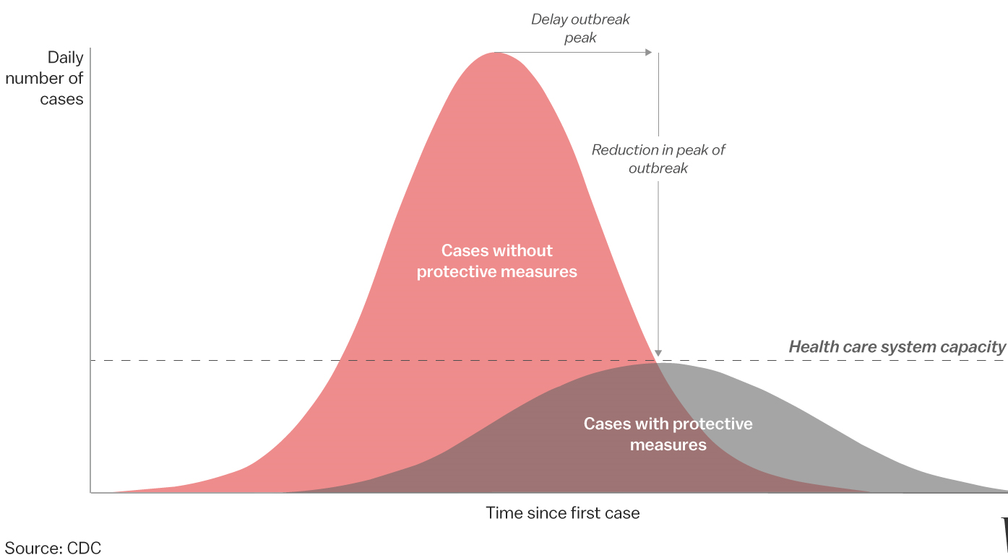
The key enabling factors in care provision at this stage are a consistent approach to deliver quality healthcare and a uniformly applied methodology for identifying those who need care. Also, there is a need to identify those who need to move to either a lower or higher level of care as their clinical course evolves. There will need to be sufficient flexibility across community and acute settings to facilitate this transition.
Ultimately, if the virus becomes established, there will be a period of intense and rapid demand followed by a time when the management of this illness with become part of business as usual (BAU). With the development of vaccination and herd immunity it is likely that the surge will pass.

1.2 Clinical Considerations
Most people infected with COVID-19 virus have a relatively mild disease and recover. The symptoms resemble viral pneumonia and range from being mild to severe. These symptoms usually develop on average 5-6 days after infection (mean incubation period 5-6 days, range 1-14 days). In general, those who get the virus break down into three groups:
- 80% of patients present with mild illness
- 14% present with severe illness
- 5% present with critical illness.
Most common symptoms : Cough, Dyspnoea, Myalgia, Fatigue, Fever
Less common symptoms: Anorexia, Sputum Production, Sore Throat, Dizziness, Headache, Rhinorrhoea, Chest pain, Haemoptysis, Diarrhoea, Nausea/vomiting, Abdominal pain Conjunctival congestion.
Risk factors for serious disease as a result of COVID-19 include:
- Age > 60 years; this is a continuum of increasing risk and is influenced by other pre-existing disease. Any specific cut-off is arbitrary, but the risk can be considered substantially higher for those > 75 years.
- Cardiovascular disease
- Diabetes
- Chronic respiratory disease
- Hypertension
- Cancer
- Immunocompromised
According to report of the WHO-China Joint Mission on Coronavirus Disease 2019 (COVID-19) February 2020, disease progression is characterised by:
- The median time from onset to clinical recovery for mild cases is approximately 2 weeks.
- For those with severe or critical disease, median time is 3-6 weeks.
- Data from the same report also suggests that the time period from onset to the development of severe disease, including hypoxia, is 1 week.
- Among patients who have died, the time frame from symptom onset to outcome ranges from 2-8 weeks.

Scope

The scope of this model is to describe the care pathway for those with suspected or diagnosed COVID-19 as the virus moves through the stages of transmission. It will be correlated with the potential locations where care will be delivered, bearing in mind that this will not be a unidirectional pathway and that it will be influenced by the patient’s clinical condition, their environment and the psychosocial circumstances of individual patients and their immediate family and/or carers.

The model includes advice for those who can stay at home, the pathways they can use if they suspect they have COVID-19, what HCWs can do from the point of initial contact, and how they can facilitate and support care at home. Once contact is made with the health service, the potential pathways for patient referral, include testing sites, community assessment hubs, intermediate care in the community and care in the acute hospital setting are set out. The response to COVID 19 requires substantial enablers including: infrastructure, workforce, technology in addition to national policy and input from public service bodies.

Guiding Principles

This model of care is guided by the following principles:

- Delivering the right care at the right time in the right place for those who develop COVID-19.
- That the healthcare system implements best possible Infection Prevention and Control practice to ensure that accessing healthcare and working in healthcare does not amplify the spread of infection.
- The response to COVID-19 requires a national population health approach and this is being led in Ireland by the National Public Health Emergency Team (NPHET) working closely with the HSE.
- Clinical and public health governance need to be closely aligned at all times, with close consideration given to both individual patients and the public’s best interests. The model of care aims to be aligned to national advice and governance structures.
- The implementation of appropriate public health measures will prevent spread and raise community awareness
- The care and management of COVID-19 requires individual citizen involvement in understanding preventative measures, applying appropriate self-management techniques and supporting others in the community.
- Enable extended workforce capability through the provision of adequate training and support.
- Maintenance of time related ‘business as usual’ functions of the healthcare system. e.g. cancer surgery, strokes, standard GP care needs.

Governance Structures

The response to COVID-19 requires a national population health approach which is being led in Ireland by the National Public Health Emergency Team (NPHET) within the Department of Health. NPHET is informed by advice issued by the European Centre for Disease Control (ECDC) and the World Health Organisation and is supported by an Expert Advisory Group (EAG).

The Health Service Executive (HSE) is working closely with NPHET to align clinical services with this population health approach. The HSE has put in place internal governance structures around its response to COVID 19 to ensure clinical oversight and alignment and integration with service operations and communications as set out in Appendix A.

The HSE Crisis Management Team (CMT) is a senior HSE group managing the operational response to COVID 19 for the HSE at national level. This group is chaired by the CEO and supported by senior operations, clinical, and communications group, the HPSC and the National Public Health Outbreak Response Team.

At a regional HSE level, there will be a co-ordinated response at the level of Community Health Organisation (CHO) geographic area, encompassing the relevant acute hospital groups. Area crisis management teams will be convened and co-chaired by the Chief Officer of the CHO and CEO of Hospital Group. This group will include heads of service, public health representatives and clinical directors and will be tasked with ensuring that the actions taken at the operational level are supported, coordinated, coherent and integrated. Local operational response teams will be based within individual hospitals and will align with instruction issued by the area crisis management team.

Model of Care

5.1 Core Principles for Stages of Disease Transmission

Each phase of disease transmission is underpinned by strong public messaging providing advice on disease prevention and encouraging self-management at home where possible. Individuals with symptoms of COVID-19 will be assessed and supported by the HSELive COVID Helpline, local testing centres and attendance at Community Assessment Hubs where necessary. Individuals who are most severely unwell will be treated in intermediate care centres or in acute hospitals. Testing for COVID-19 will take place in designated community and acute care settings and through the National Ambulance Service. Further information on how to care for people at home is available on https://www2.hse.ie/coronavirus/

Ireland has now moved from containment to delay transmission phase. The clinical focus is currently to limit and slow down the spread of the virus through the community to reduce the surge of people requiring healthcare services. The clinical management of patients with mild symptoms of COVID-19 has now shifted from hospital to home settings, including residential and congregated home settings.
In mitigation phase the clinical focus will be on identifying the cases who are most severely unwell and providing care for acutely ill patients. There will also be a requirement for a recovery phase when transitioning to normal services following the mitigation phase. This will require planning and support as there may be a surge of latent care stepped down during the pandemic.

It will be necessary to ensure that there is an interface / network between community assessment & hospital assessment/ admission to ensure that that anyone who has been discharged to homecare and requires re-admission has a rapid re-access pathway to their hospital.

The pathways of care reflect the delayed and mitigation phases and describe the clinical process in the various settings. The outline model of care for the care and management of COVID-19 across all settings is presented in Appendix B.

Specific clinical guidance relevant to the assessment and management of patients during each phase is available at https://www.hpsc.ie/.

5.2 Delay Phase Patient Pathway

The National Public Health Emergency Team met on Wednesday 11 March 2020 to review latest evidence of the spread of COVID-19. NPHET has made a recommendation that Ireland move to Transmission Delay Phase (Delay Phase).

Throughout delay and mitigation, there will be changes to the levels of essential services that can be delivered and these will be scaled up and down according to local need. This will be governed by Area Crisis Management Teams. During the Delay phase GPs will triage patients for referral to testing through Healthlink. HSELive line will support patient access to clinician triage and referral for testing for those members of the public unable to access a GP. Testing will carried out through testing centres nationally based out of some of the national network of existing HSE Primary Care Centres in addition to some testing carried out by the National Ambulance Service in the community.

Redeployment of HSE staff to COVID response and return to work protocols for those who have recently retired will be enacted. The HSELive COVID Helpline and testing process will also be supported by a COVID Care Tracker System currently in place which members of the public and certain healthcare professionals will access online (see Appendix D). This tool will support the triage of patients for testing and aid case management. Contact Tracing remains a priority for all positive diagnoses which will be tracked within the COVID Care Tracker. The patient pathway for the Delay Phase is set out in Figure 2.

Figure 2.

5.3 Mitigation Phase

The goals of mitigation phase of the COVID-19 outbreak are to provide hospitals with the necessary support to maintain essential services as the virus spreads and to provide appropriate care for individuals who are unwell in the community to reduce the overall impact of the disease on the healthcare services.

The following table sets out a framework for delivery of services across home, community and acute settings during this phase, outlining two parallel pathways of care for individuals with or without symptoms or diagnosis of COVID 19. The aims of this framework are:
- To keep the majority of individuals living well at home.
- To protect at risk groups and healthcare workers from contracting the virus.
- To provide the appropriate care to individuals with symptoms of COVID-19.
- To protect ‘business as usual’ for non-COVID healthcare services.
The implementation of this framework is based on strong public messaging to encourage self-management at home (Appendix E), with robust case management systems manned by experienced clinicians who can effectively triage patients with COVID-19 that require individual assessment. Designated community hubs will have responsibility for providing assessment and management with outreach services as required. General Practice teams will be responsible for providing non-COVID related healthcare to individuals as required, with onward referral to intermediate or acute care or discharge home as appropriate. The patient pathway for the Mitigation Phase is set out in Figure 2 with further additional information in Appendix C.
Figure 3.
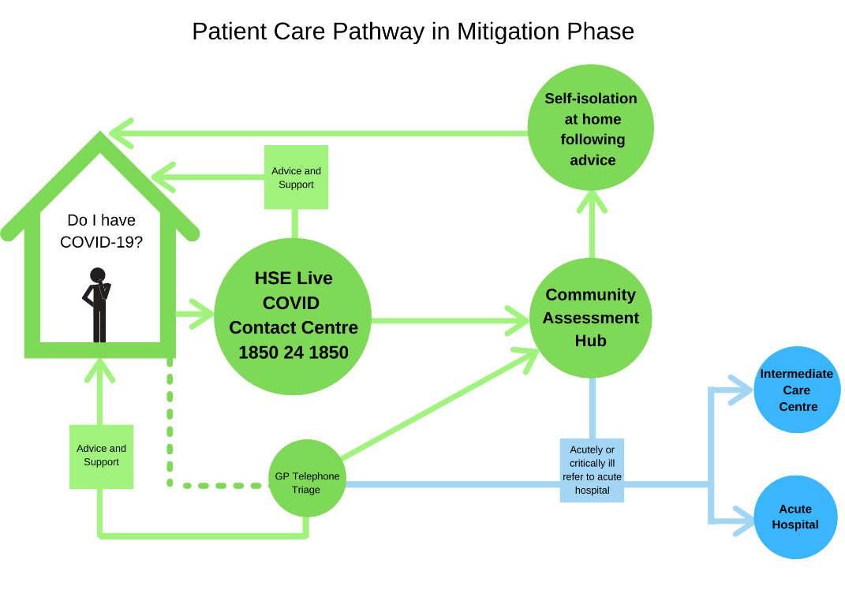

5.4 Pathways of Assessment and Management in Community Hubs and Hospital Settings

Clinical staff must be trained and know how to follow best infection prevention and control practice including how to minimise their exposure, how and when to perform hand hygiene and how and when to use appropriate personal protective euipment (PPE). Clinical assessment includes a clinical review, informed by INEWS scoring and a history including psychosocial history. The decision can be based on any one or a combination of the following:
- Patient with INEWS score of ≥3 with particular focus on respiratory rate and oxygen saturation (see Table 1)
- Clinical judgement and patient history.
- Unsuitable home environment.
Table 1. INEWS Score Card for use in recognising and knowing when to respond to deterioration
Irish National Early Warning System (INEWS) Scoring Key for use in the Community with Covid-19 March 2020
Score | 3 | 2 | 1 | 0 | 1 | 2 | 3 | Patient Observations | Score
Respiratory Rate (bpm) | ≤8 |  | 9-11 | 12 -20 |  | 21 - 24 | ≥25
SpO2 (%) | ≤91 | 92 -93 | 94 -95 | ≥96
Inspired O2 (FiO2) |  |  |  | Air |  |  | Any O2
Systolic BP (mmHg) | ≤90 | 91 -100 | 101 -110 | 111 - 249 | ≥250
HR (BPM) |  | ≤40 | 41 – 50 | 51 - 90 | 91 – 110 | 111 - 130 | ≥131
ACVPU/  CNS Response |  |  |  | A (Alert) |  |  | New confusion (C), Voice (V), Pain (P), Unresponsive (U)
Temp. (*C) | ≤35.0 |  | 35.1 – 36.0 | 36.1 – 38.0 | 38.1 – 39.0 | ≥39.1
Patients with an INEWS score of < 3 may be suitable to be cared for at home or in the community. |  |  |  |  |  |  |  | Total INEWS

5.5 Community Assessment Hubs

Funding has been made available for 32 community hubs the purpose of which is to divert the assessment of those with suspected or confirmed COVID-19 from General Practice / Primary Care. These hubs are likely to be existing Primary Care Centres which will be repurposed as COVID Community Assessment Hubs. The 35 locations are currently being determined.
The entire site will be used as a COVID hub, or part of the building will be assigned as the COVID hub with physical and human services for COVID-19 completely distinct and separate from other services.

Opening hours: Flexed up and down depending on demand if capacity available.

Workforce requirements
Community Assessment Hubs will be staffed by healthcare professionals and determination of the requirements is underway.

Purpose of the Community Testing Hubs
These hubs will provide testing in the community but will not necessarily evolve into assessment hubs.

Purpose of Community Assessment Hubs
The community assessment hub will provide for the examination of patients and will determine the next stage in their pathway, which can be:
- The patient goes home.
- The patient requires further monitoring -this can be referred to NEOC for follow up
- The patient requires admission to an intermediate care centre
- The patient requires admission to an acute hospital
Assessments will be completed by healthcare staff in the COVID Community Assessment Hubs either in person or via weblink. Assessment forms and decision-making tools for onward referrals will be available and are currently under construction.

An outreach service will be required to assess/ support people who cannot travel to the community assessment hub.

Preparedness actions
Preparedness where the entire building is designated as a COVID Community Assessment Hub.
- Increase environmental cleaning and preparation for decontamination between appointments
- Shift business as usual activity to alternative sites (e.g. to other primary care centres or to hotels).
- Procure supplies: protective gear, oxygen, medical equipment, signage.
Telehealth solutions in the community for end of life care are being explored.

5.6 Acute Hospitals

This section aims to provide acute hospitals and clinicians with guidance on preparedness for COVID-19 and to provide interim guidance on timely, effective and safe supportive management of patients with COVID-19, including those admitted to critical care.

The aim is to enable the delivery of Covid care while maintaining essential non-Covid care. The model of care is a parallel system, known as the ‘hospital within hospital’ service delivery model. Its purpose is to deliver a patient pathway of care that runs in parallel with existing services with as little overlap, in either infrastructure, staffing or other resources, as possible. It is likely that patients with suspected or diagnosed Covid-19 will be cohorted within the hospital setting, providing for > 1 metre between patients. The parallel system can be operated within an individual hospital or within a hospital group or region, according to the factors such as demand, geography and capacity for transfer of patients from one area to another.

Some groups may choose to designate individual hospitals within their group/region as Covid or non-Covid locations, according to the facilities available, local demand and transport capacity. Facilities needed to manage Covid patients who require critical care include best available critical care capacity and capacity to cohort. Designation will also depend on the capacity to transfer urgent medical and surgical care to those locations where non-Covid care is more easily delivered.

The advantage of this model is that it enables ‘business as usual’ (BAU) to continue as long as possible and it can flex up and down following the outbreak trajectory. The limitations are that with a system that runs at full capacity, service disruption has to occur to enable planning and preparation.
Core elements of Covid-19 Preparedness in the Acute Setting include:
- Formation of a preparedness committee in each receiving hospital, with structured formation and function.
- ECDC preparedness checklist followed.
- Capacity preparation. COVID patients may require to be cohorted as cases exceed isolation/ single rooms.
- Undetermined symptomatic patients managed in isolation/ single rooms and cohorted once viral status confirmed.

Investigations in all patients with severe illness
- Pulse oximetry
- ABG (as indicated to detect hypercarbia or acidosis)
- FBC
- Comprehensive metabolic panel
- Coagulation screen
- Inflammatory markers (serum procalcitonin)
- Serum troponin
- Serum lactate dehydrogenase
- Serum creatine kinase
- Pulse oximetry may reveal low oxygen saturation (SpO₂ <90%)
- Swab and Cultures
- Molecular Testing
- Imaging
- CXR
- CT- consider in patients with suspected pneumonia who have a normal CXR due to greater sensitivity to detect infiltrates
Management of co-morbidities
- Promptly admit patients with pneumonia or respiratory distress to an appropriate healthcare facility and start supportive care depending on the clinical presentation.
- The median time from onset of symptoms to hospital admission is reported to be approximately 7 days. Patients with impending or established respiratory failure should be referred to critical care

Supportive Therapies
Oxygen: Give supplemental oxygen at a rate of 10-15L/minute to patients with severe acute respiratory infection and respiratory distress, hypoxaemia, or shock. Titrate flow rates to reach a target SpO₂ ≥90%.

Fluids: Manage fluids conservatively in patients with severe acute respiratory infection when there is no evidence of shock as aggressive fluid resuscitation may exacerbate the condition.

Symptom Relief
Give an antipyretic/analgesic for the relief of fever and pain.

Monitoring
Monitor patients closely for signs of clinical deterioration, (use iNEWS or Irish Maternity Early Warning Score as appropriate) such as rapidly progressive respiratory failure and sepsis and start general supportive care interventions as indicated (e.g., haemodialysis, vasopressor therapy, fluid resuscitation, ventilation, antimicrobials).

Deterioration and Escalation
Patients being monitored in the community and as an in-patient on the ward may deteriorate. The iNEWS monitoring system facilitates tracking the physiological changes that may occur in a patient as the disease process evolves. Rising iNEWS score is a measure of increasing physiologic perturbation which may be adaptive and appropriate or a signal of a worsening disease process. Escalation actions occur with respect to each INEWS score and these range from no change, continue current monitoring cycle to calling for a critical care review. See escalation and response plan in Table 2:

Table 2. INEWS Escalation and Response Protocol
Total Score | Minimum Observation Frequency | ALERT | RESPONSE
1 | 12 Hourly | Nurse in charge | Nurse in charge to review if new score1
2 | 6 Hourly | Nurse in charge | Nurse in charge to review
3 | 4 Hourly | Nurse in charge & Team/On-call SHO | 1. SHO to review within 1 hour
4-6 | 1 Hourly | Nurse in charge & Team/On-call SHO | - SHO to review within hour  - Screen for Sepsis, if present get senior help  - If no response to treatment within 1 hour contact Registrar  - Consider continuous patient monitoring  - Consider transfer to higher level of care
≥7 | Hourly | Nurse in charge & Team/On-Call Registrar Inform Team/On-Call Consultant | - Registrar to review immediately  - Continuous patient monitoring recommended  - Critical care review  - Activate Emergency Response System (ERS)  (as appropriate to hospital model)
Note: Single Score triggers
Score of 2  HR ≤ 40  (Bradycardia) | Hourly | Nurse in charge & Team/On-call SHO | 1. SHO to review immediately
*Score of 3 in any single parameter | Hourly or as indicated by patient’s condition | Nurse in charge & Team/On-call SHO | - SHO to review immediately  - If no response to treatment or still concerned contact Registrar  - Consider activating ERS

Critical Care Management
Pre- critical Care
Respiratory Support in the Ward setting
- Involve critical care promptly- early intubation is key
- NIV should only occur in an isolation room, preferably negative pressure; otherwise 100% via full rebreather mask
- Never put type 1 respiratory patient on BiPAP
- Helmet CPAP may be associated with less aerosol production

Managing Hypotension in the Ward Setting
- Conservative fluid management strategy is recommended
- Consider peripheral phenylephrine while awaiting critical care input

Critical Care Management
- IPC guidance should be followed for open ward cohorting of critical care ‘virus detected’ patients.
- Non-invasive ventilation and High flow nasal oxygen therapy is not recommended outside of a negative pressure isolation room and only with careful consideration.
- Closed circuit ventilation with in-line suctioning and nebuliser. Circuit breaks for physiotherapy, suctioning or other activity in an open unit should be avoided.
- Intubation/ extubation/ proning (if circuit break a possibility or planned) or any other planned circuit break should occur after transfer into an isolation room where possible.
- Intra-hospital transports should be carefully planned and considered in terms of the potential impact on patient care vs the risks.
- Inter-hospital transport of the critically ill will be facilitated by MICAS and will include transfers for access to critical care capacity as well as transfers for specialist input. The usual transfer policies and procedures will apply.
- ECMO: extra-corporeal membrane oxygenation may be suitable for rescue oxygenation for patients following the existing protocols and practises.

5.7 Considerations for specific populations

There are some groups of people who may be more at risk of serious illness if they catch coronavirus. While they may not necessarily have a higher risk of catching coronavirus they will be at increased risk of serious illness if they catch it including:
- 60 years of age and over
- Have a long-term medical condition – for example, heart disease, lung disease, diabetes, cancer or high blood pressure.

For vulnerable groups, such asthose in mental health services, older persons, intellectual disability, social care or those with long term illness, any break in continuity of healthcare services can have deleterious effects. All efforts should be made to preserve the existing services and workforce for these groups. Telehealth solutions to support the non-COVID-19 pathway are being worked on to ensure this continuity.

Early access to testing though the NAS for residents in long term care facilities or congregated settings should be prioritised.

If required, confirmed cases should either be transferred to the most appropriate setting taking into account the particular needs of the patient and fellow residents. In residential facilities, confirmed or suspected COVID-19 cases may be segregated in a COVID – 19 unit/ward with designated staffing within that setting. This will ensure vulnerable patients with specific needs will be cared for in the appropriate environment with appropriately skilled staff for continuity of care.

In maternity and paediatric settings, care delivery should always continue as usual with the implementation of standard precautions with all patients.

Appendices

APPENDIX A: HSE & Department Health Governance Structures for COVID-19
- 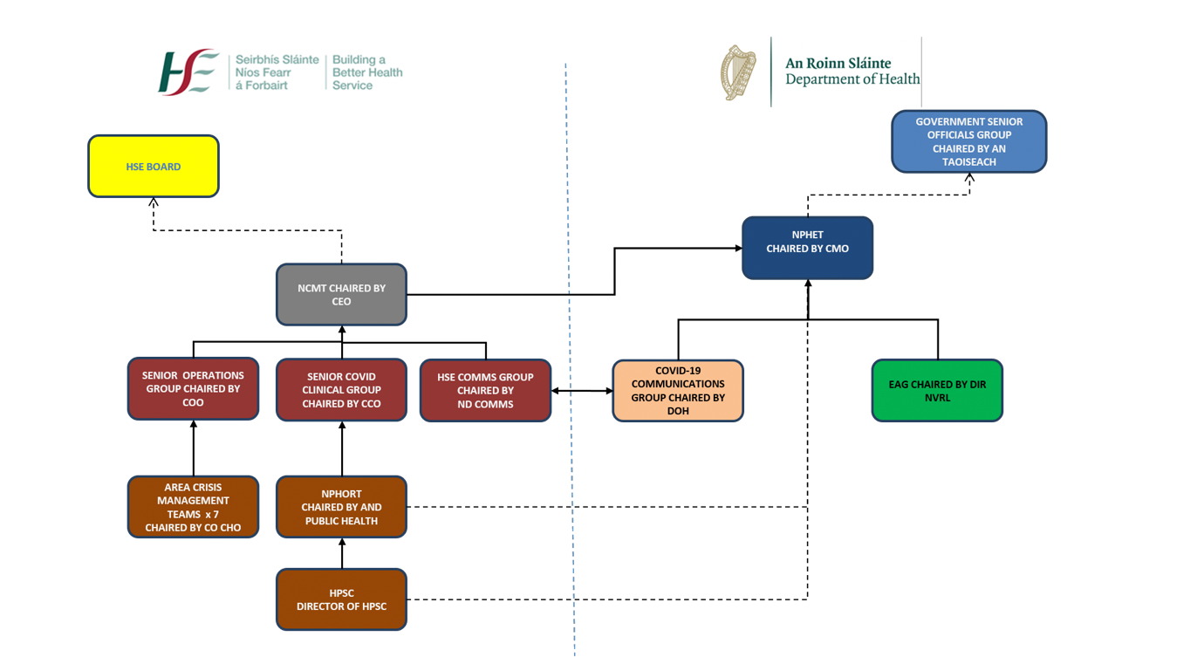

APPENDIX B: OUTLINE MODEL OF CARE
 | Containment Phase | Delay Transmission Phase | Mitigation Phase
Priority Groups | All | All | At risk groups
Clinical Focus | - Prevention  - Early identification of cases and their contacts  - Manage symptoms | - Prevention & identification of cases and their contacts  - Reduce time from symptom onset to isolation  - Manage symptoms | - Management of patients who are experiencing the most severe symptoms and critically ill.  - Advice & support for those with mild symptoms to self-manage
Identification | - Case definition  - Apply case definition and initiate risk assessments for patients via telephone or in-person.  - Testing being completed by National Ambulance Service (at home) & pop ups and in-hospital testing | - Updated case definition  - Initiate risk assessments for patients via telephone or in-person  - Some primary care centres will be designated as community assessment hubs for COVID 19 testing  - New test centres nationally & ongoing testing by NAS | - Updated case definition  - Apply case definition and initiate risk assessments for patients via telephone or in-person at designated community testing service.  - Assume symptomatic is positive  - Testing to confirm recovery on discharge
Prevention | - Contact tracing  - Self- isolation at first signs of symptoms  - Community and healthcare setting awareness and preventative infection control measures  - Isolation of all diagnosed cases in secondary care | - Increased capacity for contact tracing  - Ongoing isolation measures where appropriate  - Move to cohorting of all diagnosed cases in secondary care | - Increased capacity for contact tracing  - Social isolation measures  - Increased community and healthcare setting awareness and preventative actions/ infection control  - Co-horting of suspected cases in secondary care.
Treatment | - All diagnosed cases require admission to hospital for isolation and symptom management  - Specific clinical guidance is available on HSPC website (www.hpsc.ie) | - All diagnosed cases will not automatically require admission to hospital. Aim to deliver care as close as home to possible  - Those with COVID-19 with mild symptoms to self-isolate at home  - Clinical assessment determines care setting  - Specific clinical guidance is available on HSPC website (www.hpsc.ie) | Clinical assessment to determine appropriate setting  Suspected or confirmed COVID-19:  - mild symptoms to self-isolate at home  - require 24 hour nursing care and/or oxygen should be admitted to intermediate care.  - Acutely ill should be admitted to acute care (ICU)  Specific clinical guidance is available on HSPC website (www.hpsc.ie)
Organisation of delivery of care | - Increased public health surveillance  - Expanded helpline and online information  - Operational services continue business as usual  - National Ambulance Service delivering home assessment and testing service  - All samples for COVID-19 should be referred to National Virus Reference Laboratory | - Expanded helpline and online information.  - Some primary care centres will be designated as community assessment hubs for COVID-19 testing in addition to alternative locations. Reduce NAS home testing as appropriate  - Redefine Business as Usual for operational services. Non-essential services will be stepped back  - Diversion of non COVID activity to alternate pathways | - ongoing helpline and online information  - Community Assessment Hubs to assess/ support people at home  - Intermediate Care Centres and acute hospitals designated as COVID-19 and non-COVID-19  - Redefine Business as Usual for operational services. Non-essential services cancelled to increase capacity  - Specialist ambulatory care to be delivered virtually or via outreach
Supporting enablers | - Model of Care and Clinical Care Guidelines  - Preparing to Increase critical care and intermediate care capacity  - Infection Control and Prevention Training for staff  - Expansion of IT infrastructure  - Preparations for redeployment of HSE staff to and return to work for recently retired | - Redeployment of HSE staff to COVID response and return to work for those recently retired  - Close collaboration with other public bodies to support workforce  - Intermediate and acute hospital capacity will be expanded with a particular focus on ICU and HDU | - Updating Model of Care and Clinical Care Guidelines based on emerging evidence  - Redeployment of staff from non-essential services from non-essential services to COVID response or other essential services.  - Explore ability to house staff on-site involved in COVID 19 care of patients
Measurement | Public Health Surveillance | Public Health Surveillance

APPENDIX C: Care Pathway for suspected or confirmed COVID-19 during Mitigation Phase
HOME | HSE LIVE COVID CONTACT CENTRE | GP & PRIMARY CARE | COMMUNITY ASSESSMENT HUB | INTERMEDIATE CARE CENTRE | ACUTE HOSPITAL ED/ ICU/ HDU
Persons place of residence (including nursing home; residential homes; prisons etc.)  Purpose: Self-isolation for those with suspected COVID-19 or confirmed COVID - 19 with mild or moderate symptoms. Community supports may assist same vulnerable people at home.  Supports Available: HSE Online information; HSE Live COVID -19 contact centre; Enhanced community supports e.g. increased MOW, PHN’s, community pharmacy, medication delivery; Voluntary community supports.  Transport Arrangements:  Usual transport (e.g. family, taxis, community).  NAS responsible for transporting to acute care settings only. | HSE Live telephone or online contact centre for those with suspected COVID-19.  Entry Referral pathway: Self-referral via telehone line or online (a carer, family member or concerned healthcare professional can do this also).  Purpose: Triage, advice and onward referral for people suspected to have COVID-19.  Staffing: Mixture of non-clinical call handlers and clinical staff. Tiered triage system.  Exit Referral Pathway: Three possible outcomes of triage:  1/ Self isolate at home with advice and/or supports;  2/ Referral to community hub for testing and assessment (via HSE Live case management system).  3/ Advising to go to ED and /or calling ambulance if acutely ill  Transport Arrangements:  Getting to/from Community Hub: Usual transport (e.g. family, taxis, community transport).  NAS responsible for transporting to acute care settings only. | GP/PCC to triage and provide advice to patients  Purpose:  Via telephone assessment & refer to Community Hub (register on HSE case management) or  telephone support and advice for patients with suspected or confirmed COVID-19 in the community to avoid inpatient care.  Staffing: Existing team  Exit Referral Pathway: Three possible outcomes of triage:  1/ / Self isolate at home with advice and/or supports;  2/ Referral to community hub for testing and assessment (via HSE Live case management system).  3/ Advising to go to ED and /or calling ambulance if acutely ill  Transport Arrangements: Usual/ NAS responsible for transporting to acute care settings only. | Designated re-purposed Primary Care Centres with adequate environment for appropriate delivery of clinical care to support, access for patients, segregation and decontamination.  Entry Referral pathway: Referred via HSE Live case management system. GP’s can also access this case management system and refer patients suspected of having COVID-19.  Purpose: In mitigation phase testing will no longer be carried out. Those who are symptomatic will be assumed to be positive for COVID-19. These community hubs will provide appropriate clinical assessment, treatment and triage for onward referral. Will provide out of hours service. Opening hours will scale up and down as required. Outreach service will also be provided for non-ambulatory vulnerable patients who are not able to access the community hub. DNA to community hub will trigger phonecall to patient and next of kin.  Staffing GP’s and nursing.  Exit Referral Pathway:  Three possible outcomes of assessment determined by modified EWS:  1/ Treatment and advised to self-isolate at home with telephone follow-up.  2/ Referral to intermediate care centre faciliated by close working with bed management in intermediate care centre.  3/ Referral to ED for critically ill.  Transport Arrangements:  Getting to/from Community Hub and to intermediate care centre: Usual transport (e.g. family, taxis, community). Feasibility of using voluntary and private ambulance should be explored.  NAS responsible for transporting to acute care settings only. | Designated COVID-19 community hospitals / step down facilities/ community nursing units with piped oxygen facilities and 24 hour nursing care.*  Entry Referral pathway: Referred from community hub. Alternatively referred from acute hospital as step-down measure.  Purpose: Care of patients requiring 24 hour nursing care and/or oxygen who do not require critical care indicated by modified EWS score.  Staffing? Existing staffing in unit with additional supplementary redeployed staffing as required. 24 hour nursing care essential.  Exit Referral Pathway:  1/ Discharge home when appropriate  2/ Escalation of care to acute hospital through referral to ED (for critically ill)  Transport Arrangements:  Getting to/ from intermediate care centre from community hub: People will use their normal method of transport (e.g. family, taxis, community transport). Feasibility of using voluntary and private ambulance should be explored if required.  Transfer to intermediate care centre as stepdown from acute: National ambulance Service. Feasibility of using voluntary and private ambulance should be explored.  Transfer to acute hospital: NAS responsible for transporting to acute hospital.  * Strict cohorting and isolation of COVID-19 cases should apply regardless of whether designation of entire sites is realisable. | Designated COVID-19 Model 3 and 4 acute hospitals with ED, HDU. ICU. Designated COVID and non-COVID hospitals.*  Entry Referral Pathway: Referred from Community Hub or intermediate care centre or through ED (patient self-presentation or referral from HSE Live).  Purpose: Patients requiring critical acute care indicated by modified EWS score.  Staffing? Existing staffing in unit with additional supplementary redeployed staffing as required.  Exit Referral Pathway:  1/ Discharge home  2/ De-escalation of care to stepdown intermediate care centre.  Transport Arrangements:  Getting to acute care: NAS responsible for transporting to acute care settings.  Getting home from acute care: People will use their normal method of transport (e.g. family, taxis, community transport). Feasibility of using voluntary and private ambulance should be explored if required.  Transfer to intermediate care centre as stepdown from acute via NAS. Feasibility of using voluntary and private ambulance should be explored.

APPENDIX D: CONTACT MANAGEMENT SYSTEM
The COVID Care System is a case management system that has been developed to support the management of calls logged to HSELive COVID helpline from members of the public. This system will be able to support the management of those patients that may be referred on for testing. On phoning the COVID helpline, callers will be triaged by a call handler and then added via the case management system to a worklist for clinical follow up, if appropriate. Clinical follow-up will consist of two levels and callers will be triaged to either level depending on the acuity of their conditions. Guidance and decision support tools to assist this process are currently in development. Referral onward for testing or to the Community Assessment Hub will be via an appointment scheduling tool (Swiftqueue). Patients will the receive automated communications containing their appointment details. All positive COVID cases will be tracked on this system. The system process is set out below.
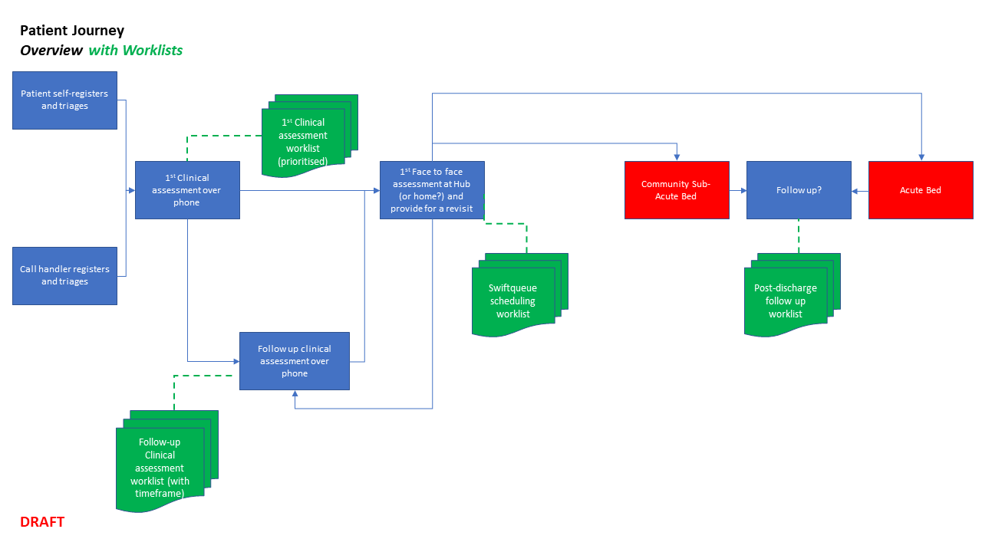
This solution is also designed to enable GP and Primary Care Centres to register patients on the case management system and to manage and track their testing schedule and results pathway.

Figure 3.

APPENDIX E: COVID – 19 Self Care Plan
